Client Recording & Consultation Form

Client Details

(Mr / Mrs / Miss / Ms) First Name…………………………….…………………….Surname………………………………………..…………………….
D.O.B……………………………………………………..…..……. Male / Female
Address………………………………………………………………………………………………………………….……………………………………………………..
Contact Number :………………………………………..…………………………Email : ......………………..………………………………………………....

In case of an emergency contact

Name……………………………………………………………………………. Contact Number ………………………………..………………………………..
Relationship…………………………………………………………………………………………………………………..……………………………………………..

Client Lifestyle Details

Occupation……………………………………………………………………………………………………………………………………………………………………
Physically related work activities ……………………………………………………..…………………………………………………………………………..
Hobbies / Interests / Activities ……………………………………………………………………………………………………………………………………..
……………………………………………………………………………………………………………………………………………………………………………………..

GP Details

Name ………………………………………………………………………Contact Number…………………………………………..…………………………….
Surgery Name………………. ……………………………………………………………………………………………………………………………………….…….
Address.………………………………………………………………………………………………………………………………………………………………………..

Medical History
Do you have, or have you had in the past 6 months, any of the following listed on the contraindications sheet?
YES / NO Please give details ………………………………………………………………………………………………………………………..……………….
Have you visited your GP/Consultant to carry out the treatment?
(Please attach letter) YES / NO (require when treating clients with GP referral contraindications)
I fully understand that thorough and honest responses to these questions are essential to my safety. I hereby confirm that the information stated above is accurate to the best of my ability and I undertake to inform my practitioner of any changes.
I further understand that prior to any treatment a physical assessment needs to be carried out. The procedure has been fully explained to me and I am happy to proceed.
Client Signed ……………………………………………………………..……………….. Date …………………………………………….
Therapist Signed………………………………………………………………………….. Date …………………………………………….

Confidential

Reason to visit

Subjective History

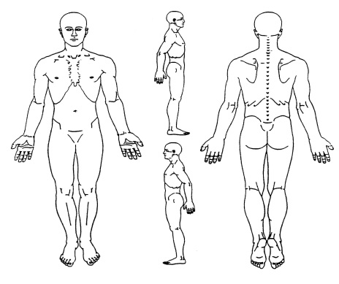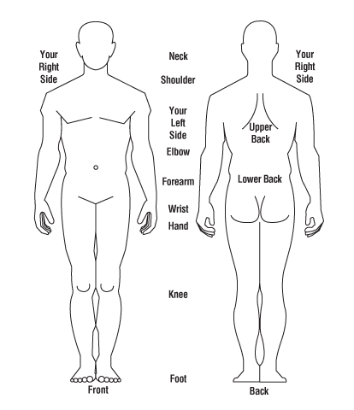

Objective findings
P(n) = Painful 1-10, F = Functionally short, ROM = Range of motion, W = Weakness, or Other
Joint : | Active |  | Passive |  | Resisted
Joint Action | L | R | L | R | L | R

Assessment (subjective and objective findings)
P(n) = Painful 1-10, F = Functionally short, ROM = Range of motion, W = Weakness, or Other

Summary of finding and proposed action plan
Clinical findings | Proposed action
Structure and findings | Therapist | Client

I hereby give my consent for the therapist to continue with the treatment outlined above.

Client’s Signature……………………………………………………………………………. Date …………………………………………
Therapist’s Signature………………………………………………………………………. Date …………………………………………

Contraindications Checklist
Please read the following carefully and inform your Sports Massage Practitioner if you currently have, or have had in the past 6 months, any of the following symptoms / conditions:
Musculoskeletal Issues: e.g. Strains / Sprains / Fractures / Myositis /Joint Replacement /Arthritis /Osteoporosis / Bursitis /Tendonitis / other
Circulatory Issues: e.g. Heart Condition / Hypertension / Hypotension / DVT (Deep vein thrombosis) / Phlebitis / Varicose Veins / Haemophilia /CV disease / other
Neurological Issues: e.g. Epilepsy / Sciatica / Neuralgia / MS / Parkinson / other
Skin Issues: e.g. Eczema / Acne / Athletes Foot / Warts / Dermatitis / Psoriasis / Impetigo / Cuts / Bruises / Burns / Undiagnosed Lumps / other
Respiratory Issues: e.g. Asthma / Pneumonia / Bronchitis / Sinusitis / Cold / Cough / Flu / other
Immune Issues: e.g. Cancer / Rheumatoid Arthritis /HIV / AIDS / other
Digestive Issues: e.g. IBS (Irritable bowel syndrome) / Constipation / Diarrhoea /Gall Stones / Kidney Stones /Urinary Tract Infection / other
Miscellaneous Issues: e.g. Diabetes / Allergies /Recent Operations / Major Operations /Pregnancy / Unstable Pregnancy / Glandular / Fever / Headaches / Psychological Issues / Menstrual Issues / Substance Abuse / Feeling Unwell / other

